| Exp.No.4 | Series and parallel connection |
| --- | --- |
| Date:  4-11-2021 |

**Aim :**To study the properties of series and parallel connection.

**Apparatus:**

LT spice software tool

**Circuit diagram:**

**Series circuit:**

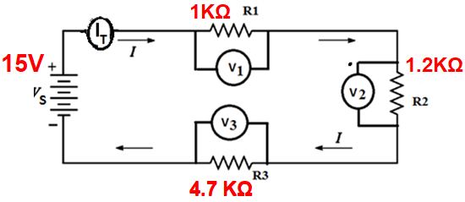

VS=V1+V2+V3

Parallel circuit:

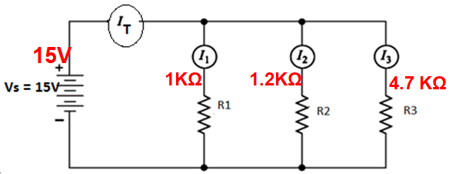

IT=I1+I2+I3

**Procedure:**

1. Draw the series and parallel circuits in the LT Spice schematic.
2. Apply the voltage and resistance values.
3. Label the nodes at appropriate places in the circuit.
4. Go to simulate tab and select edit simulation command
5. Select operating point analysis in the edit simulation command..
6. Run the simulation
7. Calculate the potential difference across each resistor and check for VS=V1+V2+V3
8. Calculate the current through each resistor and check for IT=I1+I2+I3

**Theoretical calculations:**

Write the calculations done in the class

**Comparison of theoretical values to the simulated values:**

|  | Theoretical value | Simulated value |
| --- | --- | --- |
| VS(volt) |  |  |
| IT(mA) |  |  |

**Result:**

The properties of series and parallel circuits are studied through simulation and verified successfully.

**Inferences:**

The theoretical value is the same as the simulated value and hence verified successfully.